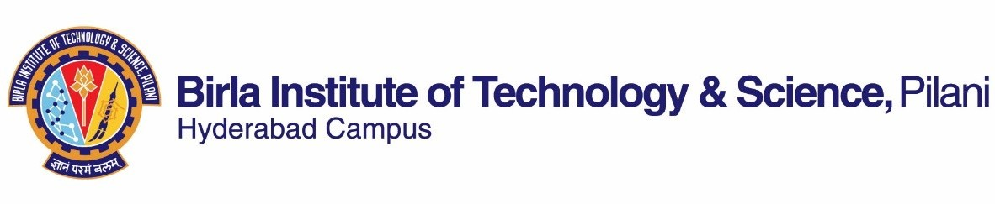

# SECONDSEMESTER2022-2023

CourseHandoutPartII

Date:09-01-2024

Inadditiontopart-I(GeneralHandoutforallcoursesappendedtothetimetable)thisportiongivesfurtherspecificdetailsregardingthecourse.

**CourseNo. :**MATH F342

**CourseTitle :**DifferentialGeometry

**Instructor-in-Charge :**Sumit Kumar Vishwakarma

Nameofthe Tutors :Jahir Abbas SardarandHirendra Kumar Garai.

**Scope and Objective of the Course:** The objectiveof this course is to provide a systematic exposition of theessential concepts of moderndifferentialgeometry, and an understanding and appreciation for the intrinsicbeautyofthese concepts, as wellastheirdeep relationships to physical Sciences.The under current is togeneralizeandreinforcetheclassicalsubjectinamodernway.

# Textbooks:

1.AndrewPressley–ElementaryDifferentialGeometry,2ndEdition(CorrectedPrint),Springer(2012).

# Referencebooks

1. D.Somasundaram,DifferentialGeometryAFirstCourse,NarosaPublishingHouse,FirstEdition,2012.
2. GrayA,AbbenaE,SalamonS–ModerndifferentialgeometryofcurvesandsurfaceswithMATHEMATICA,3rdEdition,CRCPress(2006).
3. Oprea,J–DifferentialGeometryandItsApplications,MathematicalAssociationofAmerica(2007).

# CoursePlan:

|  |  |  |  |
| --- | --- | --- | --- |
| **LectureNo.** | **Learningobjectives** | **Topicstobecovered** | **Chapterinthe TextBook** |
| 1-4 | Localand  globaltheoryofcurves. | Parameterized curves, reparameterization, arclength,levelcurvesvsparameterizedcurves. | 1.1-1.4 |
| 5-8 | Curvatureofregularplaneandspacecurves. | 2.1-2.3 |
| 9-11 | Simple closed curves in the plane, theisoperimetricinequality,thefourvertextheorem. | 3.1-3.3 |
| 12-16 | To understand basic conceptsregardingsurfacein3dimensionalspace, examplesofsurfaces. | Conceptsofasurface,smoothness,tangentspace and normal vector, orientability,examplesof surfaces. | 4.1-4.4 |
| 17-20 | Measurements along surfaces,geometricinvarianceunderbending.  Various ways of determining howfastthesurfacecurves(curvatures). | The first fundamental forms, isometries ofsurfaces, conformal mappings of surfaces,surface area. | 5.1-5.4 |
| 21-25 | Thesecondfundamentalform,thecurvatureof curves on a surface, normal and principalcurvatures,geometric interpretationofprincipal curvatures. | 6.1-6.4 |

|  |  |  |  |
| --- | --- | --- | --- |
| 26-30 | Howonedetermines thecurvature? | Gaussian and mean curvatures, surfaces ofconstant Gaussian curvature and theirclassificationandexamples,theGaussmap. | 7.1 and7.3-7.6 |
| 31-34 | Shortestpathsbetweentwopointsofasurface. | Definition and basic properties of geodesic,geodesicequations,behaviorunderisometry,geodesicsonsurfacesofrevolution, shortest  paths. | 8.1-8.5 |
| 35-38 | Gaussian curvature is preservedunder bending, existence anduniquenessofsurfaceswithgiven1stand2ndfundamentalforms.  Gauss-Bonnet Theorem relates theEuler characteristic (a topologicalinvariant) with the curvature (ageometricinvariant)ofthesurface. | Gauss’s remarkable theorem, isometries ofsurfaces and The Coddazzi- Mainardiequations. | 10.1-10.3 |
| 39-40 | TheGauss-BonnetTheoremforcompactsurfaces. | 11.3 |

**EvaluationScheme:**

|  |  |  |  |  |
| --- | --- | --- | --- | --- |
| **Component** | **Duration** | **Weightage (%)** | **Date&Time** | **Nature ofComponent** |
| Quiz | 20 minutes | 10 | TBA | OpenBook |
| Assignment | - | 10 | TBA | Open Book |
| Mid-sem | 90minutes | 35 | **16/03/2024 (2:00-3:30 PM)** | ClosedBook |
| ComprehensiveExam | 3hours | 45 | **18/05/2024(FN)** | ClosedBook |

* **Chamberconsultationhour:**Tobeannouncedintheclass.
* **TotalMarks:100**
* **Notices:**ThenoticesconcerningthiscoursewillbedisplayedontheCMSNoticeBoardonly.
* **Make-upPolicy:**Make-upwillbegivenonlyforverygenuinecasesandpriorpermissionhastobeobtainedfromtheI/C.
* **AcademicHonestyandIntegrityPolicy:**Academichonestyandintegrityaretobemaintainedbyallthestudentsthroughoutthesemesterandnotypeofacademicdishonestyisacceptable.

**INSTRUCTOR-IN-CHARGE**

**MATHF342**